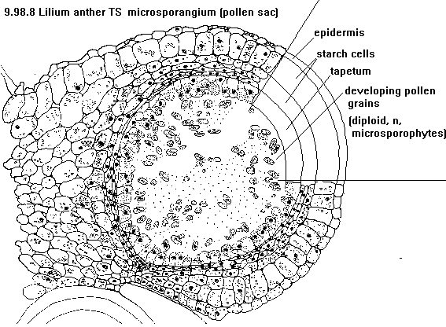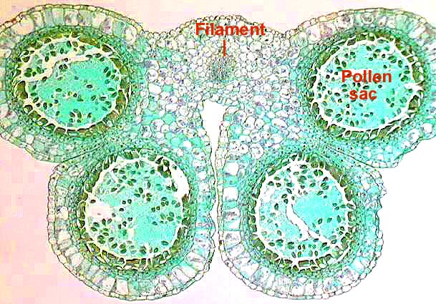

http://www.lima.ohio-state.edu/biology/archive/flowers.html

http://www.uq.edu.au/_School_Science_Lessons/UNBiology1a.html

**Diagrams and microscope pictures of lily anthers.**

**Dehisence** is the term used to describe when the **tapetum** of the anther matures, dries out and breaks releasing the mature pollen grains from within the pollen sac.

Remember the diploid cell in the pollen sac is a **microspore** due to its relatively small size as a gamete.

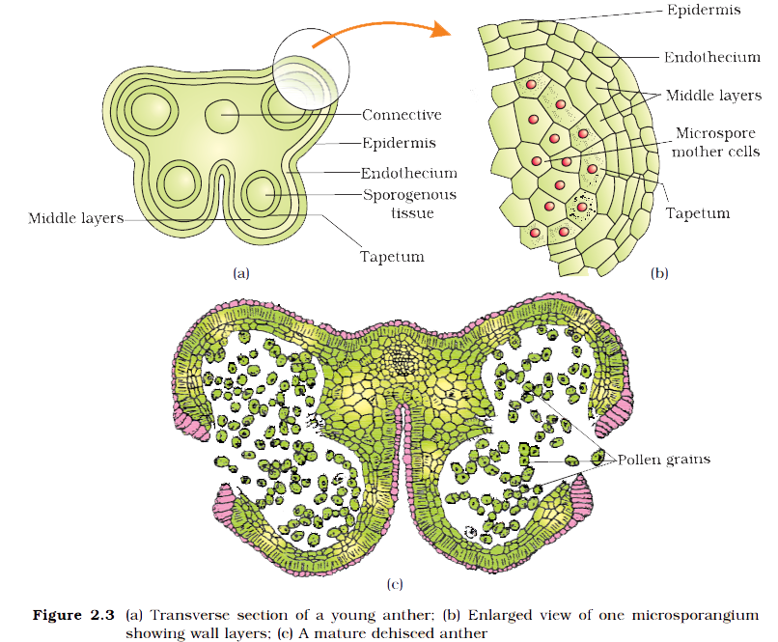

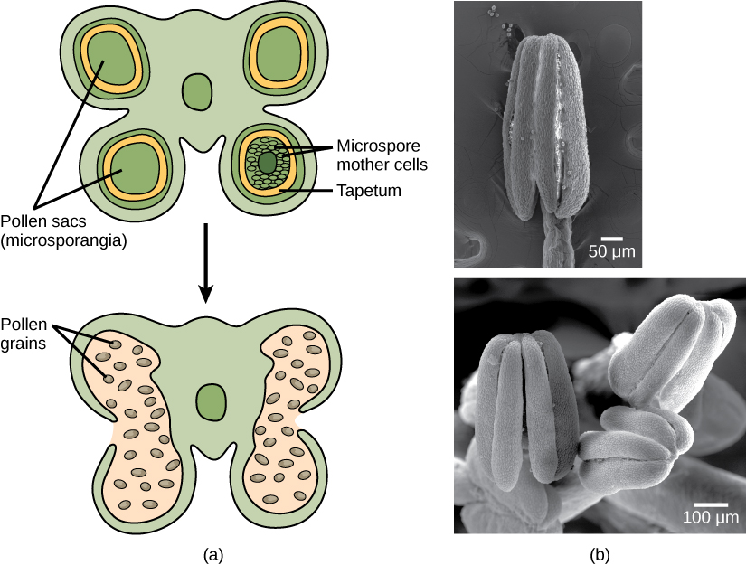

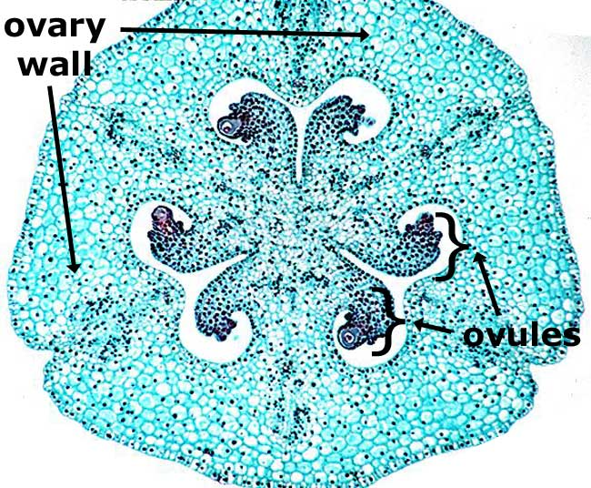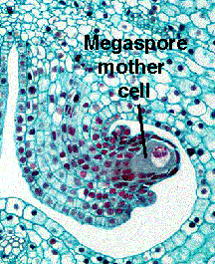 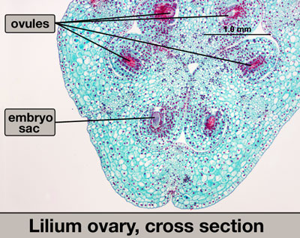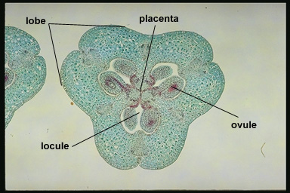

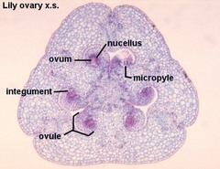

**Microscope pictures of lily ovaries.**

The ovary of a lily actually contains 6 ovules each of which contains its own embryo sac. This is true of many plants and is the reason why you find several pips in the middle of an apple